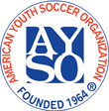 | 2026 Beach Classic Tournament  AYSO Open Invitational  Team Application Form | 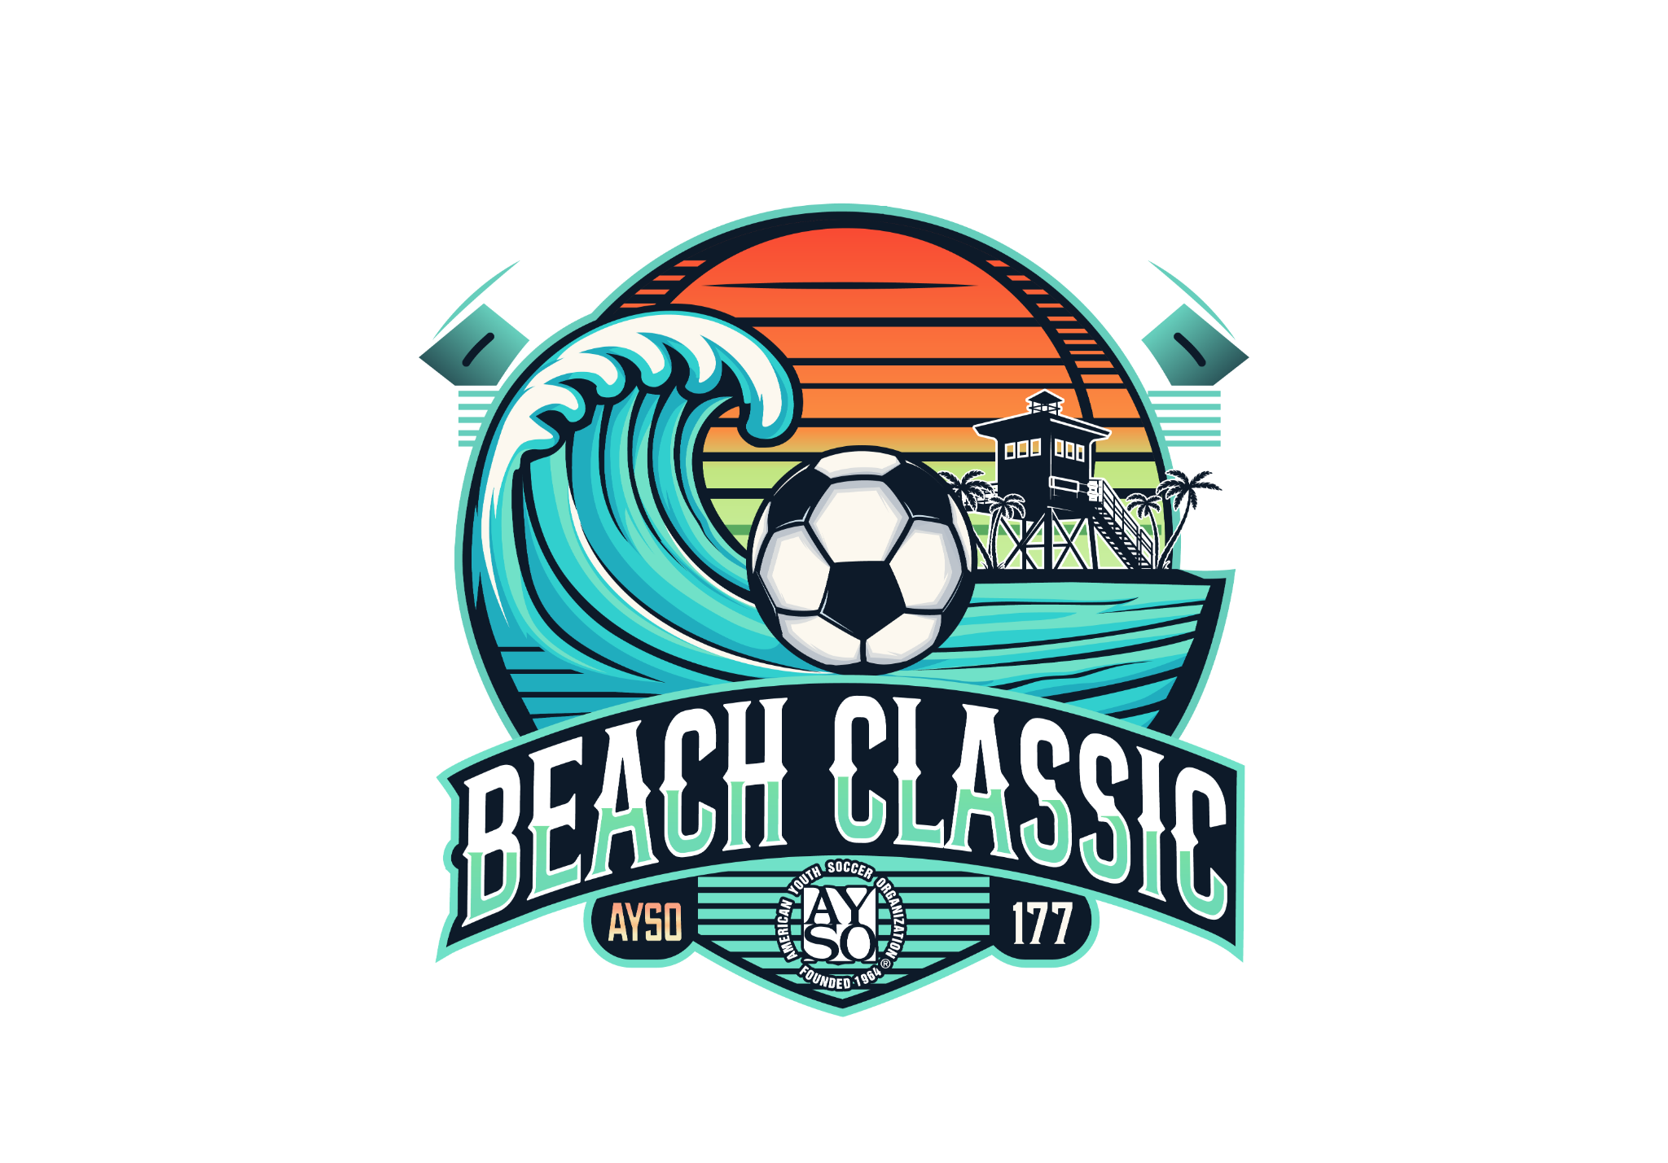

Application Instructions

Applications are now being accepted for entrance into the Beach Classic AYSO Open Invitational Tournament.
The deadline to enter the tournament is Feb 6, 2026. Applications accepted by that date will be given priority for acceptance into the tournament; all others will be accepted based on any available openings.
Applications will be accepted on a first-come basis, based on a completed application. To be considered complete, your application must include all of the following:
- Team Application Form, signed by the Head Coach and the Regional Commissioner or Organization President/Registrar
- A single Regional / Organization check for the total amount of the Team Entry Fee and the Referee Commitment Deposit.
Team fees are: Age Division Team Entry Fee Referee Deposit Total Fee
U11 / U12 (9v9) $550 $300 $850
U09 / U10 (7v7) $500 $300 $800
Send your completed application and Regional/Organization Check to: Tournament Director
AYSO Beach Classic Tournament
161 Claremont Ave, Long Beach, CA 90803
Required immediately after acceptance:
- The completed Referee Form signed by your organization's appropriate Referee Administrator (if you’re not planning to bring referees, just check the box on the Referee Form and return it without signature).

Required at Saturday Check-in:
- Team Roster Form signed by your Regional Commissioner or Organization President/Registrar
- Alternatively, AYSO teams may submit a Blue Sombrero Roster form, however it must include the names of the Head Coach and Assistant Coach and be signed by your Regional Commissioner.
- Rosters are final after Check-in.
- Rosters must be composed solely of players who were registered to play in the just concluded AYSO / Organization primary season program.
- Player roster limits are as follows:
9-v-9 play 12 players max
7-v-7 play 10 players max
- Medical Release forms with wet or electronic signatures.
- Player ID cards with photo, name, player #, DOB, & Organization Info

If accepted, it will be assumed that you intend for your team to play the entire tournament.
If your application is not accepted, you will be offered the opportunity to be placed on a waiting list, or if you prefer we will return your application to you.
Refund: if you withdraw your application 14 or more days from the start of the tournament, a full refund will be issued. If you withdraw after that time, we will only issue a refund if a replacement team can be found, less any cost to register that replacement team.
All information about the tournament can be obtained by visiting our website at www.ayso177.org
Please note that email and the internet will be the primary means of communication for this tournament.
We will be sending out information via email newsletter once your application is received. In the meantime, if you have any further questions, you may contact us as follows: Catherine Bebb
E-mail 177beachclassic@gmail.com
Website www.ayso177.org

2026 Beach Classic Tournament
AYSO Open Invitational

Team Application Form
Section: |  |  |  |  | Area: |  |  |  |  |  |  |  |  |  | Region Organization |  |  |  |  | Region/Organization Name: |  |  |  |  |  |  |  |  |  |  |  | Application Date: |  |  |  |  | _____
Team Name:
Age Division & Gender (circle): |  |  |  |  |  |  |  |  |  |  |  |  |  | U09 |  | U10 | U11 |  | U12 |  |  |  | 7v7 |  |  | 9v9 |  |  |  |  |  |  |  | Boys |  | Girls
Contact Information
Coach Name: |  |  |  |  |  |  |  |  |  |  |  |  |  |  |  |  |  | Asst. Coach Name:
Email: |  |  |  |  |  |  |  |  |  |  |  |  |  |  |  |  |  | Email:
Mailing Address: |  |  |  |  |  |  |  |  |  |  |  |  |  |  |  |  |  | Mailing Address:
City/State/Zip: |  |  |  |  |  |  |  |  |  |  |  |  |  |  |  |  |  | City/State/Zip:
Evening Phone Number: |  |  |  |  |  |  |  |  |  |  |  |  |  |  |  |  |  | Evening Phone Number:
Emergency Phone Number: |  |  |  |  |  |  |  |  |  |  |  |  |  |  |  |  |  | Emergency Phone Number:
AYSO/Organization ID#: |  |  |  |  |  |  |  |  |  |  |  |  |  |  |  |  |  | AYSO Organization ID#
Certification Level: |  |  |  |  |  |  |  |  |  |  |  |  |  |  |  |  |  | Certification Level:
Safe Haven Date: |  |  |  |  |  |  |  |  |  |  |  |  |  |  |  |  |  | Safe Haven Date:
Shirt Size: |  |  | AS AM AL AXL AXXL |  |  |  |  |  |  |  |  |  |  |  |  |  |  | Shirt Size: |  |  |  | AS AM AL AXL AXXL
Team Rating Criteria:
1) We are an Allstar/Select Team, the only one from our region. |  |  |  |  | Yes |  |  | No
2) We are an Allstar/Select Team, one of |  | teams in this age division from our region. |  |  | Yes |  |  | No
3) We are a Fall regular-season team. |  |  |  |  | Yes |  |  | No
4) My team competitive rating between 1 (low) and 10 (high) is
5) The average age of our players as of January 1, 2026 is
Team Head Coach Approval:
 | Yes, I have read the tournament rules and I promise to abide by them. I also am committed to returning on the alternative dates should the tournament be rescheduled due to inclement weather, etc.
 | Yes, I understand that this is a 2-day tournament and that the medal round games are on the second day. I hereby notify you that I will NOT be able to complete the tournament for the following reason:
Coach Signature
Regional Commissioner or Organization President/Registrar Approval: Yes, the above team has my permission to attend the Beach Classic Open Invitational Tournament. Please report any behavior problems to me immediately. I understand that players from outside my region (Guest Players) will need approval as well from the Guest Player Regional Commissioner/Organization President
I hereby approve the addition of |  |  |  |  |  |  |  | Guest Players for this team.
Print Name |  |  |  | Signature (in red or blue ink only, please)
Email: |  |  |  | Best Phone:
The Referee Refund Check should be mailed to:
AYSO Region /Organization Treasurer
Send Check to Attention of:
Mailing Address:
City / State / Zip

